Overall Belonging
=== Descriptive Statistics: Sense of Belonging ===
Mean: 7.26
Median: 8.00
Mode: 8.00
Standard Deviation: 1.90
Minimum: 1.00
Maximum: 10.00

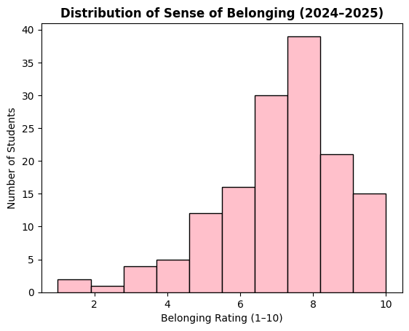

Overall Housing Satisfaction
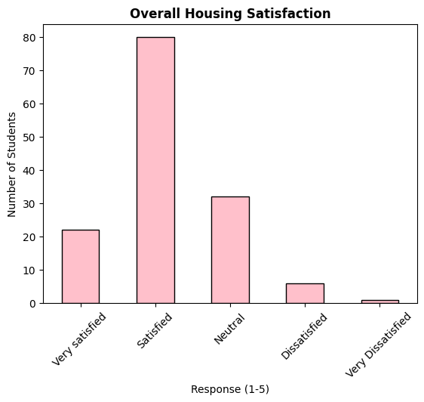

Sense of Community in Residence Halls
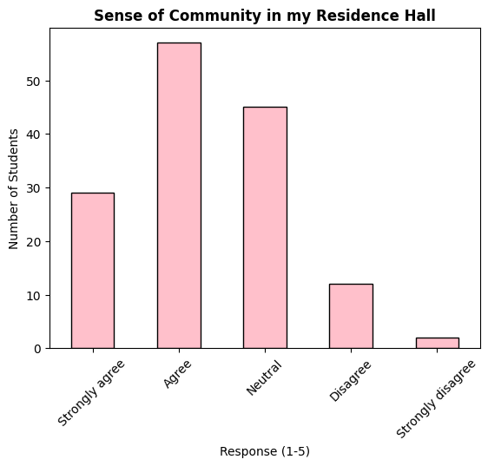

Safety at Night
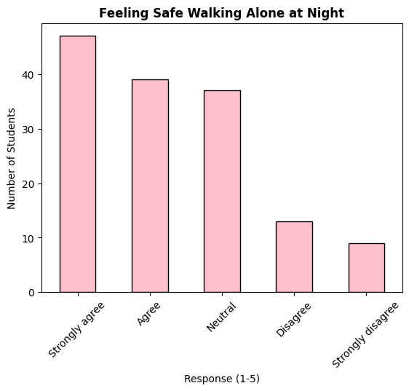

Sense of Belonging by Hall
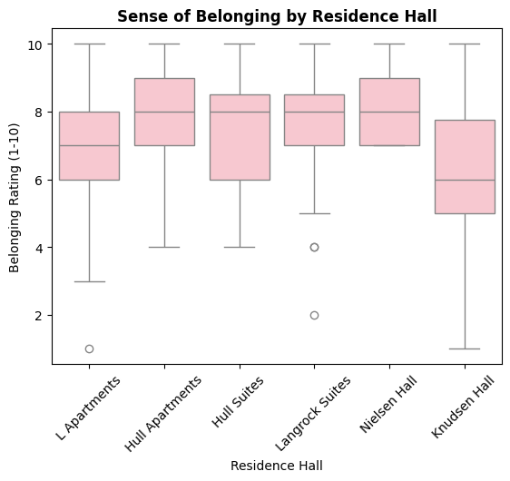

Dislikes